Database Basics MS SQL Exam – 04 Apr 2023
Exam problems for the "Database Basics" course @ SoftUni.
Submit your solutions in the SoftUni Judge system at Judge.

Accounting

Section 1. DDL (30 pts)
You have been given the E/R Diagram of the Accounting database.
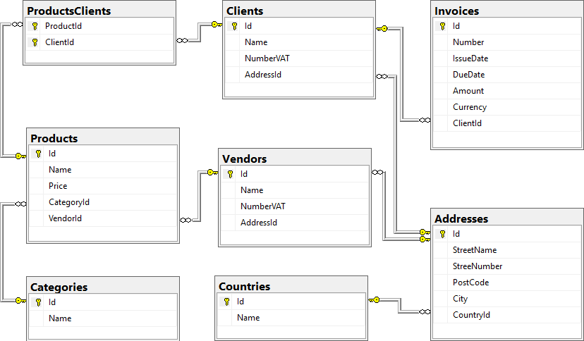
Create a database called Accounting. You need to create 8 tables:
- Products – contains information about each product;
- Categories – containts information about each product's category;
- Vendors – contains information about the products' vendors;
- Clients – contains information about the clients, which the products have been sold to;
- Addresses – contains information about the clients' and vendors' addresses;
- Countries – contains information about the countries, in which the addresses are located;
- Invoices – contains information about the invoices, issued to the clients;
- ProductsClients – mapping table between products and clients.

NOTE: Keep in mind that Judge doesn't accept "ALTER" statement and square brackets naming (when the names are not keywords).
NOTE: Please keep in mind that in case you have to work with a date, you have to use the exact same data type, described in the models tables. If you don't use the correct type, the Judge system won't accept your submission as correct.
You have been tasked to create the tables in the database by the following models:

Countries
Column Name | Data Type | Constraints
Id | Integer from 0 to 2,147,483,647 | PK, Unique table identification, Identity
Name | String up to 10 symbols | Null is not allowed

Addresses
Column Name | Data Type | Constraints
Id | Integer from 0 to 2,147,483,647 | PK, Unique table identification, Identity
StreetName | String up to 20 symbols, Unicode | Null is not allowed
StreetNumber | Integer from 0 to 2,147,483,647 | Null is allowed
PostCode | Integer from 0 to 2,147,483,647 | Null is not allowed
City | String up to 25 symbols | Null is not allowed
CountryId | Integer from 0 to 2,147,483,647 | Relationship with table Countries, Null is not allowed

Vendors
Column Name | Data Type | Constraints
Id | Integer from 0 to 2,147,483,647 | PK, Unique table identification, Identity
Name | String up to 25 symbols, Unicode | Null is not allowed
NumberVAT | String up to 15 symbols, Unicode | Null is not allowed
AddressId | Integer from 0 to 2,147,483,647 | Relationship with table Addresses, Null is not allowed

Clients
Column Name | Data Type | Constraints
Id | Integer from 0 to 2,147,483,647 | PK, Unique table identification, Identity
Name | String up to 25 symbols, Unicode | Null is not allowed
NumberVAT | String up to 15 symbols, Unicode | Null is not allowed
AddressId | Integer from 0 to 2,147,483,647 | Relationship with table Addresses, Null is not allowed

Categories
Column Name | Data Type | Constraints
Id | Integer from 0 to 2,147,483,647 | PK, Unique table identification, Identity
Name | String up to 10 symbols | Null is not allowed

Products
Column Name | Data Type | Constraints
Id | Integer from 0 to 2,147,483,647 | PK, Unique table identification, Identity
Name | String up to 35 symbols, Unicode | Null is not allowed
Price | Decimal, up to 18 digits, 2 of which after the decimal point | Null is not allowed
CategoryId | Integer from 0 to 2,147,483,647 | Relationship with table Categories, Null is not allowed
VendorId | Integer from 0 to 2,147,483,647 | Relationship with table Vendors, Null is not allowed

Invoices
Column Name | Data Type | Constraints
Id | Integer from 0 to 2,147,483,647 | PK, Unique table identification, Identity
Number | Integer from 0 to 2,147,483,647 | Unique, Null is not allowed.
IssueDate | DateTime2 | Null is not allowed
DueDate | DateTime2 | Null is not allowed
Amount | Decimal, up to 18 digits, 2 of which after the decimal point | Null is not allowed
Currency | String up to 5 symbols | Null is not allowed
ClientId | Integer from 0 to 2,147,483,647 | Relationship with table Clients, Null is not allowed

ProductsClients
Column Name | Data Type | Constraints
ProductId | Integer from 0 to 2,147,483,647 | PK, Unique table identification, Relationship with table Products, Null is not allowed
ClientId | Integer from 0 to 2,147,483,647 | PK, Unique table identification, Relationship with table Clients, Null is not allowed

Database design
Submit all of yours CREATE statements to Judge (only the creation of tables).

Section 2. DML (10 pts)
Before you start, you have to import "Dataset.sql ". If you have created the structure correctly, the data should be successfully inserted.
In this section, you have to do some data manipulations:

Insert
Let's insert some sample data into the database. Write a query to add the following records into the corresponding tables. All IDs should be auto-generated.

Products
Name | Price | CategoryId | VendorId
SCANIA Oil Filter XD01 | 78.69 | 1 | 1
MAN Air Filter XD01 | 97.38 | 1 | 5
DAF Light Bulb 05FG87 | 55.00 | 2 | 13
ADR Shoes 47-47.5 | 49.85 | 3 | 5
Anti-slip pads S | 5.87 | 5 | 7

Invoices
Number | IssueDate | DueDate | Amount | Currency | ClientId
1219992181 | 2023-03-01 | 2023-04-30 | 180.96 | BGN | 3
1729252340 | 2022-11-06 | 2023-01-04 | 158.18 | EUR | 13
1950101013 | 2023-02-17 | 2023-04-18 | 615.15 | USD | 19

Update
We've decided to change the due date of the invoices, issued in November 2022. Update the due date and change it to 2023-04-01.
Then, you have to change the addresses of the clients, which contain "CO" in their names. The new value of the addresses should be Industriestr, 79, 2353, Guntramsdorf, Austria.

Delete
In table Clients, delete every client, whose VAT number starts with "IT". Keep in mind that there could be foreign key constraint conflicts.

Section 3. Querying (40 pts)
You need to start with a fresh dataset, so recreate your DB and import the sample data again ("Dataset.sql").

Invoices by Amount and Date
Select all invoices, ordered by amount (descending), then by due date (ascending).
Required columns:
- Number
- Currency

Example
Number | Currency
213573806 | BGN
219066487 | EUR
320983369 | USD
349121203 | BGN
… | …

Products by Category
Select all products with "ADR" or "Others" categories. Order results by Price (descending).
Required columns:
- Id
- Name
- Price
- CategoryName

Example
Id | Name | Price | CategoryName
69 | Steel armor for trailer | 1350.00 | Others
15 | Air bag for trailer | 130.06 | Others
17 | Break pads for trailer | 89.60 | Others
10 | Groupage board-Load limiter | 79.33 | ADR
… | … | … | …

Clients without Products
Select all clients without products. Order them by name (ascending).
Required columns:
- Id
- Client
- Address

Example
Id | Client | Address
8 | JUAN Y ENRIQUE SANCHEZ GA | Carretera de Madrid 240, Albacete, 20080, Spain
12 | ROMO BELLIDO SOCIEDAD LIM | Carretera 330, Carinena, 50400, Spain

First 7 Invoices
Select the first 7 invoices that were issued before 2023-01-01 and have an EUR currency or the amount of an invoice is greater than 500.00 and the VAT number of the corresponding client starts with "DE". Order the result by invoice number (ascending), then by amount (descending).
Required columns:
- Number
- Amount
- Client

Example
Number | Amount | Client
219066487 | 891.76 | B & H TRANSPORT LOGISTIK
320983369 | 704.48 | BTS GMBH & CO KG
365934879 | 615.15 | FAHRZEUGBEDARF KOTZ & CO
… | … | …

Clients with VAT
Select all of the clients that have a name, not ending in "KG", and display their most expensive product and their VAT number. Order by product price (descending).
Required columns:
- Client
- Price
- VAT Number

Example
Client | Price | VAT Number
TALLERES MAVIMA SL | 1350.00 | ESB26163097
DPS EUROPE AB | 375.00 | SE556488676901
B & H TRANSPORT LOGISTIK | 309.76 | ATU53998900
… | … | …

Clients by Price
Select all clients, which have bought products. Select their name and average price (rounded down to the nearest integer). Show only the results for clients, whose products are distributed by vendors with "FR" in their VAT number. Order the results by average price (ascending), then by client name (descending).

Example
Client | Average Price
FRANZ SCHMID GMBH & CO K | 9
BTS GMBH & CO KG | 14
JOSEF PAUL GMBH & COKG | 15
… | …

Section 4. Programmability (20 pts)

Product with Clients
Create a user-defined function, named udf_ProductWithClients(@name) that receives a product's name.
The function should return the total number of clients that the product has been sold to.

Example
Query
SELECT dbo.udf_ProductWithClients('DAF FILTER HU12103X')
Output
3

Search for Vendors from a Specific Country
Create a stored procedure, named usp_SearchByCountry(@country) that receives a country name. The procedure must print full information about all vendors that have an address in the given country: Name, NumberVAT, Street Name and Number (concatenated), PostCode and City (concatenated). Order them by Name (ascending) and City (ascending).

Example
Query
EXEC usp_SearchByCountry 'France'
Output
Vendor | VAT | Street Info | City Info
LE RELAIS DES PRIMEURS | FR64431553163 | Rue de la Gare 17 | Taule 29670
SARL HEBERGECO | FR75532664075 | Route de Orleans 37 | Evreux 27000
… | … | … | …

